**Module 2 Analysis**

**By Siobhan Scott**

**Overview**

My goal was to deliver Steve and his parents a spreadsheet with stock comparisons that would help them visualize what stocks were profitable in the years 2017 and 2018. Steve’s parents were particularly interested in the stock “DQ” and it’s performance.

The first sheet I created has an input box to ask what year they would like to review. It returns the stocks for that year and includes a timer of how long the code ran. My first spread sheet ran less efficiently.

Below are the results from the 2017 before refactoring:

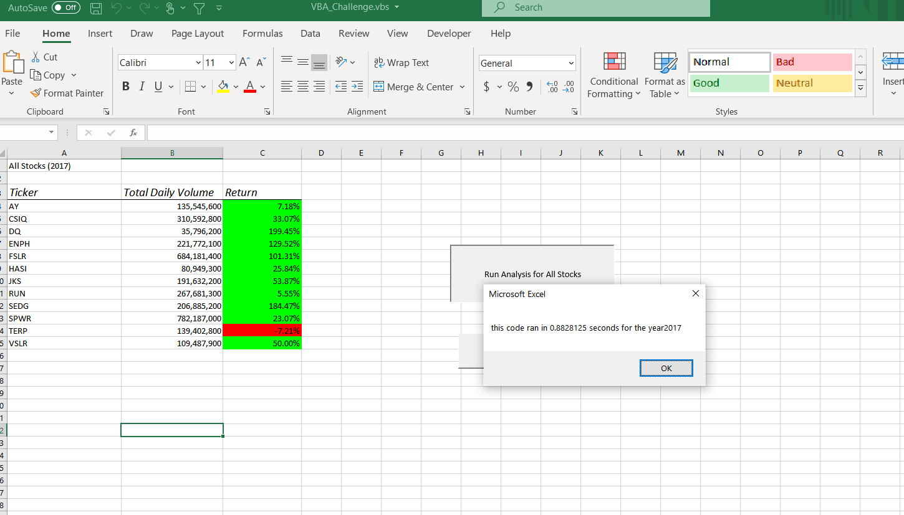

Below are the results from the 2018 before refactoring:

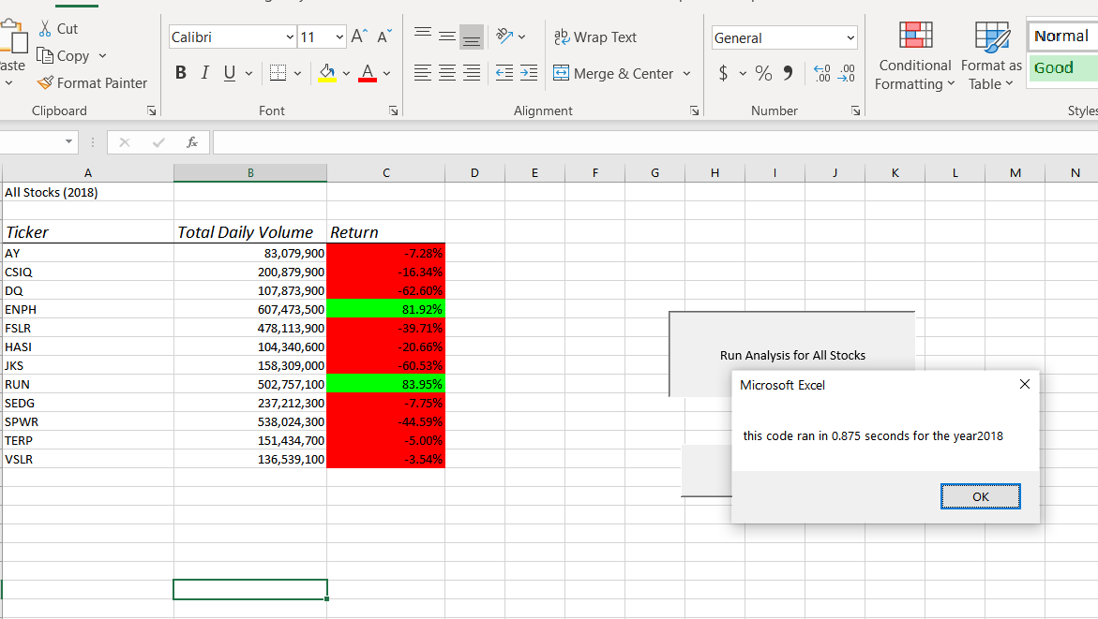

Below is the refactored 2017 sheet:

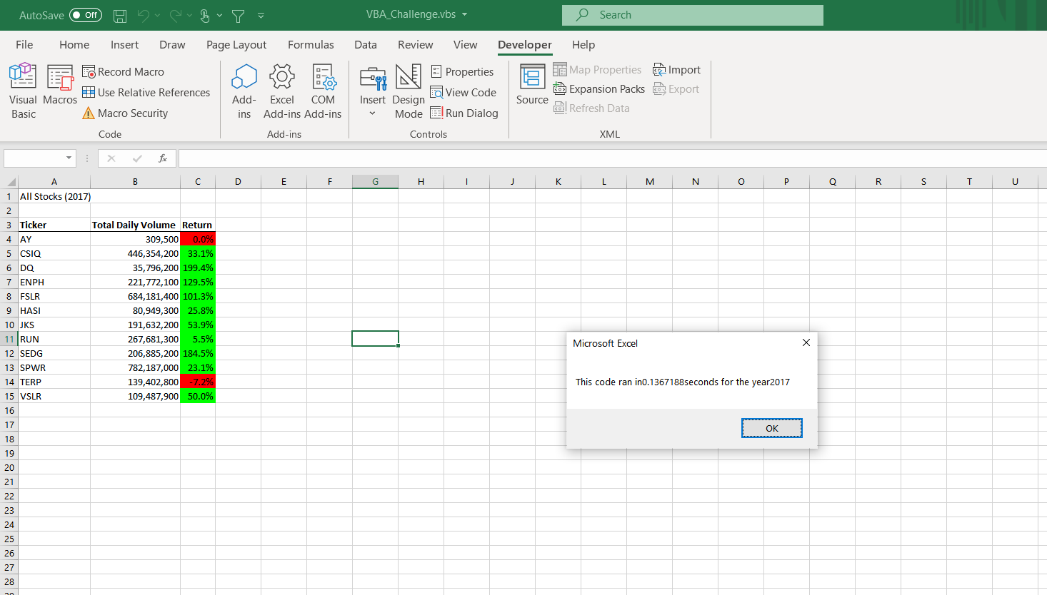

Below is the 2018 refactored sheet:

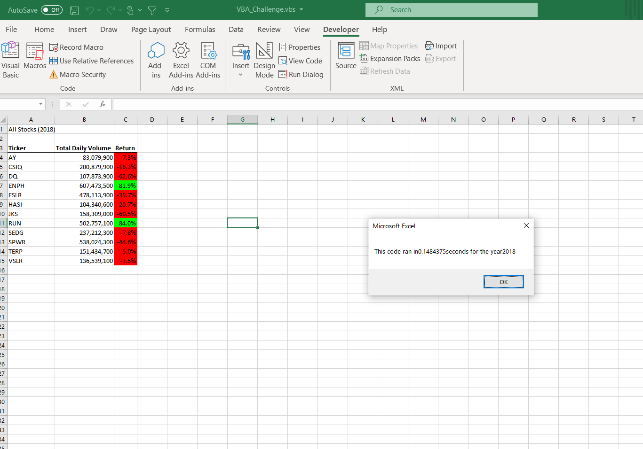

**Advantages & Disadvantages**

I refactored my code to make it run more efficiently the second time. This meant using VBA to refine my code so that it loops efficiently the first time through. Refactoring helps to reduce redundant codes to increase functionality. The disadvantage is having to redo code that you or someone lese have written and deciphering the correct code and outcome. It is time consuming and takes lots of patience. Using VBA may also not be the most efficient program to use to analyze the results especially if they are not in Excel or a Microsoft product.

**Conclusion**

Steve and his parents should not buy stock in “DQ” as it was not profitable, and they may concern investing in something else. Refactoring the spreadsheet allowed Steve to be able analyze the results more efficiently.